Temasek Polytechnic

School of Informatics and IT

**Diploma in Information Technology (IT)**

Project Plan

**Project Particulars**

|  |  |
| --- | --- |
| **Tutor** | **Mr. Mel Goh** |
| **Class** | **P02** |
| **Project Title** | **Delonix Regia Hotel Management System** |

**Project Team’s Particulars**

|  |  |
| --- | --- |
| **Matric Number** | **Student Name** |
| **1500169F** | **Camille Pamela Anne S. Sioson** |
| **1502015I** | **Dixon Low Yi Sheng** |
| **1506381A** | **Raeburn Timothy Nigel** |
| **1502527C** | **Muhammad Nur Afnan Bin Abdul Rahim** |

Revision History

|  |  |  |  |
| --- | --- | --- | --- |
| **Date** | **Version** | **Description** | **Author** |
| <8/5/17> | <1.0> | <Project plan for implementing a system for Delonix Regia> | <Camille, Afnan, Timothy, Dixon Low> |

Contents

1 Introduction 1

1.1 Objectives and scope of the project 1

1.2    Assumptions and constraints 1

1.3 Definitions and acronyms 1

2 Roles and responsibilities 1

3 Estimates and project schedule 2

3.1 Work breakdown structure 2

3.2 Project Schedule 3

3.3 Budget Summary 3

4 Risk Management Plan 4

5 Work Load Distribution 4

# **1 Introduction**

## **1.1 Objectives and scope of the project**

The objectives of the project are to be able to implement a system for the hotel which will enhance their organisation. It is to benefit the guests and as well as the staff. With having a system, it will simplify the day to day basis of the processes that happens in the hotel. Having the system would also be beneficial to the guests as the system will be able to take care of the services needed by their guests. With the implementation of this system to the hotel, it will bring about efficiency of information retrieval as well.

The features that will be developed are cloud computing, self-check-in and multi-language. And, we would carry out the necessities of the hotel and its management. As such are reservation system which will keep track of the room or banquet reservation and availability. Also, we will have the room management system which is to manage different types of room and its corresponding room services. The front office system which manages the checking-in and out of the customers and as well as housekeeping. We would also have the HR department system where it manages and staff-related administration such as their payroll etc.

The deliverables that the project is expected to deliver is a fully-functional hotel management system that will be able to address the reservation system, room management system, front office system, HR department system and implementing the cloud computing, self-check-in and multi-language.

## **1.2    Assumptions and constraints**

The software used to implement the system may cause a huge amount of money and the client which is Mr. and Mrs. Wang has agreed to spend the amount of money to build the system. It is assumed that they will not change their decision on the next phases of the software development. We also assume that they are using an OS which is compatible to what we are going to implement. Otherwise, a change in the SRS should be done accordingly.

## **1.3 Definitions and acronyms**

OS – Operating System

SRS – Software requirements Specifications

HR – Human Resources

Iter - Iteration

# **2 Roles and responsibilities**

Guests/Users who potentially can be guests

* Sign In/Join membership with the hotel (Afnan)
* Book a room (Afnan)
* Details on banquets (Afnan)
* Check and update reservations (Camille)
* Delete reservations (Camille)
* Housekeeping (Camille)
* Early Check-in (Dixon)
* Rates and Availabilities of rooms (Dixon)

Front Office

* Check for reservations (Dixon)
* Check In/Check Out of Guests (Timothy)

HR

* Pay rolls of the staff (Timothy)
* The number of staffs in each department (Timothy)

# **3 Estimates and project schedule**

## **3.1 Work breakdown structure**

**Inception Phase Iter 1**

* Complete Term of Reference
* Complete Project Plan
* Create Initial use case & domain
* Lifecycle Objectives Milestone

**Elaboration Phase Iter 1**

* Complete SRS
* Design Software Architecture
* Prototype user interface
* Lifecycle Architecture Milestone

**Implementation Phase Iter 1**

* Designing
* Programming
* Compiling
* Release 1

**Testing Phase Iter 1**

* Final Composition
* Testing Phase 1
* Customer Analyst Feedback
* Release 2

**Testing Phase Iter 2**

* Improvement
* Testing Phase 2
* Customer Analyst review
* Beta Release

**Deployment Phase Iter 1**

* Training of staff
* Final Release

## **3.2 Project Schedule**

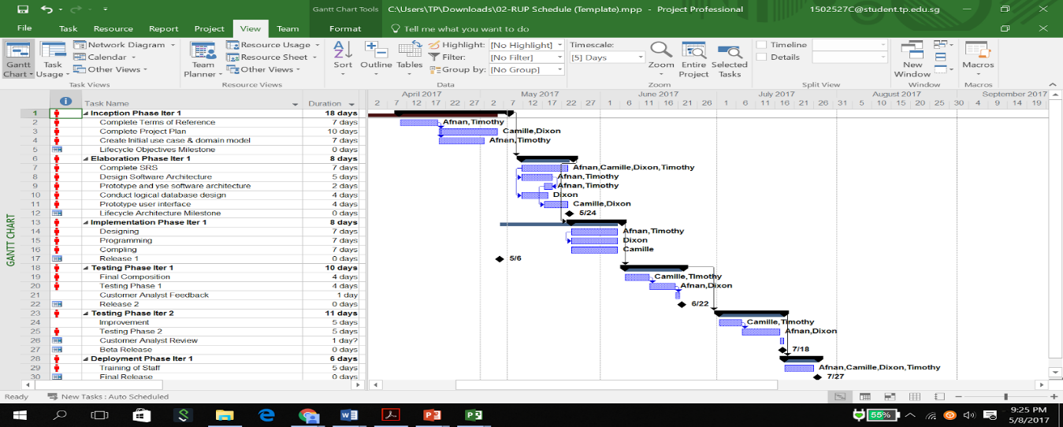

## **3.3 Budget Summary**

Monthly salary of a salary of a software engineer: $4166

A typical duration of a software project usually spans about 10 months.

Gathering requirements and analysis: 1.5 months

Design: 2 months

Coding and unit testing: 4 months

Deployment and integration testing: 2 months

User acceptance testing : 2 weeks

Total: 10 months

Manpower cost:

4 software engineer salary ($16,664) X  duration(10 months)

= $166,640

Hardware cost

* Servers: $40,000
* PC: $4000 (4 PC)
* Cloud service: 2TB Google Drive storage  ($239.76)
* Printers and scanner: $4000 (4 printers)
* Backup devices: $3000 (Budget set aside in case of failure of any devices)

Software Cost

* IBM Rational Functional Tester (1 year): $1190.00
* Visual Studio Professional: $1831.00 (New), $1220.00 (Renewal)
* Microsoft Project Professional 2016: $1159.99
* Macromedia Dreamweaver(v.8): $169.97
* Database user licences: $5000

**Overall budget: $227,230.72**

# **4 Risk Management Plan**

One possible project risks could be that the developer resigns. The severity of impact towards the project would be high. The likelihood of it occurring would be low. Risk reduction strategies would be risk mitigation, which is to offer attractive incentives to developers to keep them working.

Another possible project risk could be that user insisting on major requirements change during design. The severity of impact towards the project would be high. The likelihood of it occurring would be moderate (medium). Risk reduction strategies would be risk avoidance, which is to change the scenario or condition to avoid this risk, which will be getting the user to confirm that the requirements are what he/she wants before we move on to the design phase as it will be difficult to make changes once the design phase is reached.

# **5 Work Load Distribution**

|  |  |
| --- | --- |
| Camille | Objectives and scopes, Assumptions and constraints, Definition and Acronyms |
| Dixon | Risk Management Plan, Roles and responsibilities |
| Timothy | Estimates and project schedules |
| Afnan | Estimates and project schedules |